Lab – Researching Broadband Internet Access Technologies (Instructor Version)

**Instructor Note**: Red font color or Gray highlights indicate text that appears in the instructor copy only.

1. Objectives

Part 1: Investigate Broadband Distribution

Part 2: Research Broadband Access Options for Specific Scenarios

1. Background / Scenario

Although broadband Internet access options have increased dramatically in recent years, broadband access varies greatly depending on location. In this lab, you will investigate current broadband distribution and research broadband access options for specific scenarios.

1. Required Resources

Device with Internet access

1. Investigate Broadband Distribution

In Part 1, you will research broadband distribution in a geographical location.

* 1. Research broadband distribution.

Use the Internet to research the following questions:

* + 1. For the country in which you reside, what percentage of the population has broadband Internet subscriptions? _______________

As of Oct. 2012, 72.4% of Americans have a broadband Internet connection (88 million households).

* + 1. What percentage of the population is without broadband Internet options? _______________

9 % of Americans currently have no broadband Internet options.

* 1. Research broadband distribution in the United States.

Navigate to the website [www.broadbandmap.gov](http://www.broadbandmap.gov). The National Broadband Map allows users to search and map broadband availability across the United States.

**Note**: For access options and ISPs for locations outside the United States, perform an Internet search using the keywords “broadband access XYZ, where XYZ is the name of the country.

* + 1. Enter your zip code, city and country that you would like to explore and click **Find Broadband**. List the zip code or city in the space provided. ________________________________________________ Answers will vary.
    2. Click **Show** **Wired** and **Expand All**. What, if any, wired broadband Internet connections are available at this location? Complete the table below. Answers will vary. See table below for examples.

|  |  |  |
| --- | --- | --- |
| **ISP** | **Connection Type** | **Download Speed** |
| Time Warner | Cable | 10-25 Mb/s |
| Frontier | ADSL | 6-10 Mb/s |
|  |  |  |

* + 1. Click **Show** **Wireless** and **Expand All**. What, if any, wireless broadband Internet connections are available in this location? Complete the table below. Answers will vary. See table below for examples.

|  |  |  |
| --- | --- | --- |
| **ISP** | **Connection Type** | **Download Speed** |
| Omnicity | Fixed Wireless | 1.5-3 Mb/s |
| Verizon | Mobile Wireless | 768 Kpbs-1.5 Mp/s |
| Sprint-Nextel | Mobile Wireless | 768 Kpbs-1.5 Mp/s |

* + 1. Return to the home page and click **Explore Map**. The interactive map allows you to explore the geographical availability of a number of broadband Internet options.
    2. Highlight each of the wired connections independently (DSL, cable, and fiber). Selections are highlighted in dark blue.

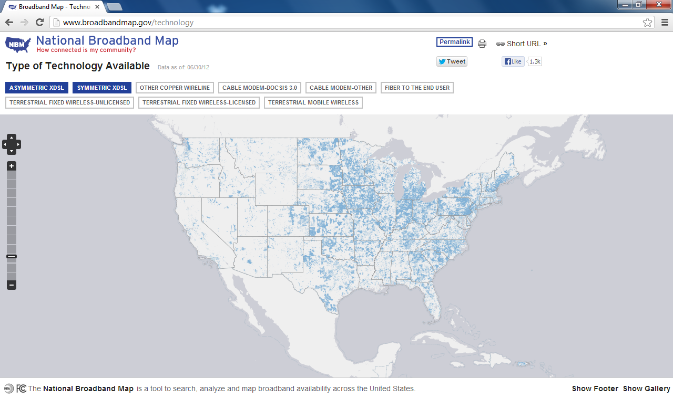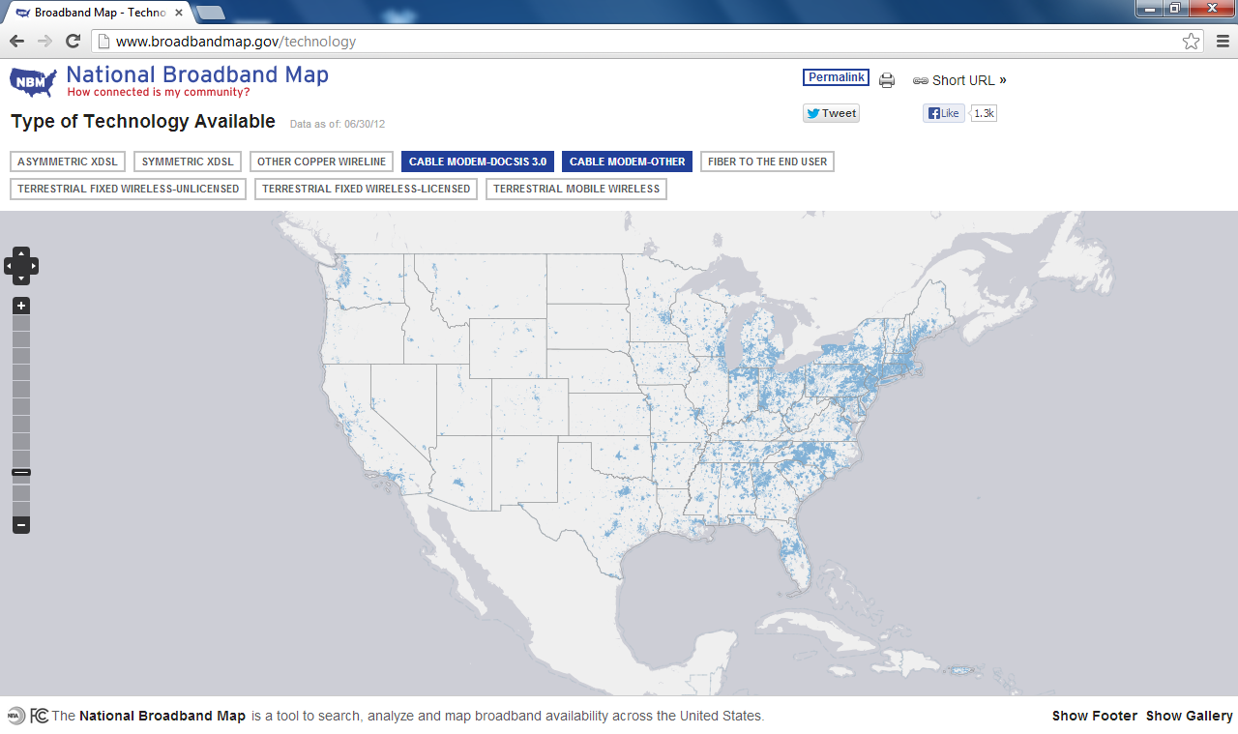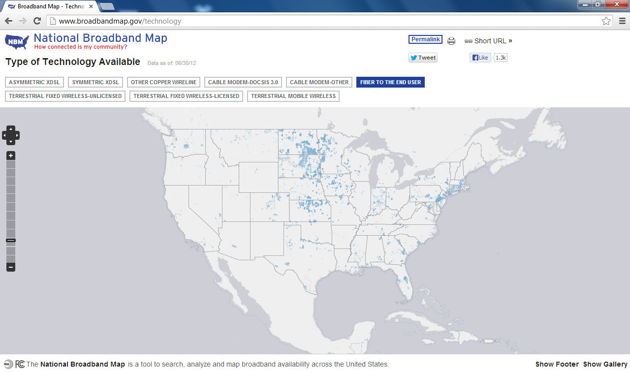

For wired connections, order the wired broadband connections from least to greatest in terms of geographical area covered. List your answer in the space provided.

____________________________________________________________________________________

Fiber, cable, and DSL

* + 1. In the gallery of maps at the bottom of the web page, select **Broadband Availability Across Demographic Characteristics**. Display the population by **density** and compare the broadband connection to the population distribution of the United States. What correlations can be drawn?

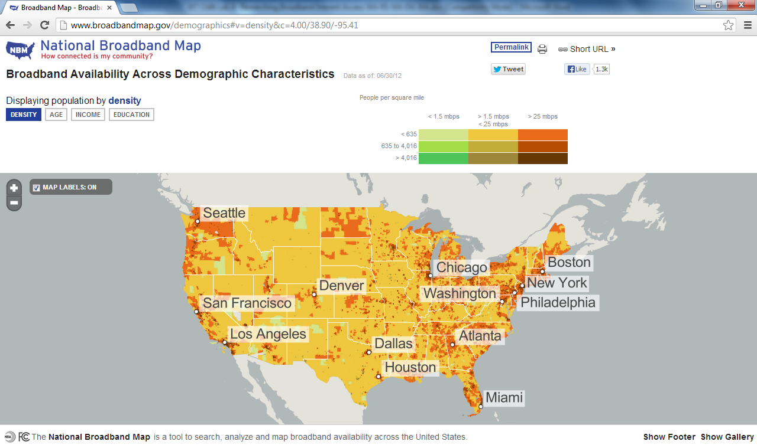

____________________________________________________________________________________

____________________________________________________________________________________

____________________________________________________________________________________

Broadband access and speed is typically proportional to population density.

1. Research Broadband Access Options for Specific Scenarios

In Part 2, you will research and detail broadband options for the following scenarios and select the best last- mile technology to meet the needs of the consumer. You can use the <http://www.broadbandmap.gov> site as a starting point for your research.

**Scenario 1**: You are moving to Kansas City, Missouri and are exploring home Internet connections. Research and detail two Internet connections from which you can select in this metropolitan area.

|  |  |  |  |
| --- | --- | --- | --- |
| **ISP** | **Connection Type** | **Cost per Month** | **Download Speed** |
| Google Fiber | Fiber | $70 | 1 Gb/s |
| Time Warner | Cable | $79 | 50 Mb/s |

Choose one from the list of local ISPs that you selected. Give the reasons why you chose that particular ISP.

_______________________________________________________________________________________

_______________________________________________________________________________________

_______________________________________________________________________________________

Answers will vary. The reasons are typically based on price per month, Internet speeds, or packages offered.

**Scenario 2**: You are moving to an area outside of Billings, Montana and are exploring home Internet connections. You will be beyond the reach of cable or DSL connections. Research and detail two Internet connections from which you can select in this area.

|  |  |  |  |
| --- | --- | --- | --- |
| **ISP** | **Connection Type** | **Cost per Month** | **Download Speed** |
| Rural Broadband | Fixed Wireless | $40 | 3 Mb/s |
| Hughes Net | Satellite | $60 | 5 Mb/s |

Choose one from the list of local ISPs that you selected. Give the reasons why you chose that particular ISP.

_______________________________________________________________________________________

_______________________________________________________________________________________

_______________________________________________________________________________________

Answers will. The reasons are typically based on price per month, Internet speeds, or packages offered.

**Scenario 3**: You are moving to New York City and your job requires you to have 24 hours anytime/anywhere access. Research and detail two Internet connections from which you can select in this area.

|  |  |  |  |
| --- | --- | --- | --- |
| **ISP** | **Connection Type** | **Cost per Month** | **Download Speed** |
| Clear | Mobile Wireless | $50 | 6 Mb/s |
| Sprint | Mobile Wireless | $80 for 12 Mb | 6 Mb/s |

Choose one from the list of local ISPs that you selected. Give the reasons why you chose that particular ISP.

_______________________________________________________________________________________

_______________________________________________________________________________________

_______________________________________________________________________________________

Answers will vary. The reasons are typically based on price per month, Internet speeds, or packages offered.

**Scenario 4**: You are small business owner with 10 employees who telecommute in the Fargo, North Dakota area. The teleworkers live beyond the reach of cable Internet connections. Research and detail two Internet connections from which you can select in this area.

|  |  |  |  |
| --- | --- | --- | --- |
| **ISP** | **Connection Type** | **Cost per Month** | **Download Speed** |
| Century Link | DSL | $29.99 | 12 Mb/s |
| I29 | WiMAX | $39.99 | 3 Mb/s |

Choose one from the list of local ISPs that you selected. Give the reasons why you chose that particular ISP.

_______________________________________________________________________________________

_______________________________________________________________________________________

_______________________________________________________________________________________

Answers will vary. The reasons are typically based on price per month, Internet speeds, or packages offered.

**Scenario 5**: Your business in Washington, D.C. is expanding to 25 employees and will need to upgrade your broadband access to include equipment colocation and web hosting. Research and detail two Internet connections from which you can select in this area.

|  |  |  |  |
| --- | --- | --- | --- |
| **ISP** | **Connection Type** | **Cost per Month** | **Download Speed** |
| Comcast | Cable | 369.95 | 100 Mb/s |
| Windstream | DSL | 129.99 | 6 Mb/s |

Choose one from the list of local ISPs that you selected. Give the reasons why you chose that particular ISP.

_______________________________________________________________________________________

_______________________________________________________________________________________

_______________________________________________________________________________________

Answers will vary. The reasons are typically based on price per month, Internet speeds, or packages offered.

1. Reflection

How do you think broadband Internet access will change in the future?

_______________________________________________________________________________________

_______________________________________________________________________________________

_______________________________________________________________________________________

_______________________________________________________________________________________

Answers will vary. Broadband Internet access will increase in geographical size and in speed with the further development of wired and wireless technology and infrastructure. Access options and speeds will continue to increase and with more availability to un-served and underserved areas.